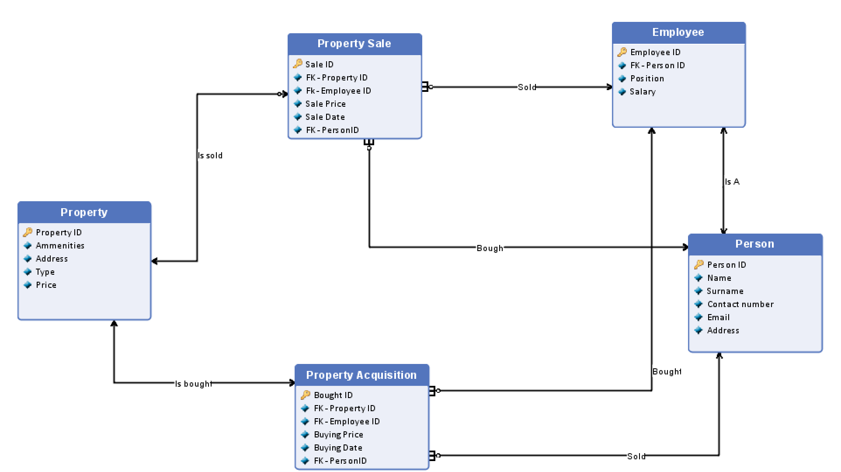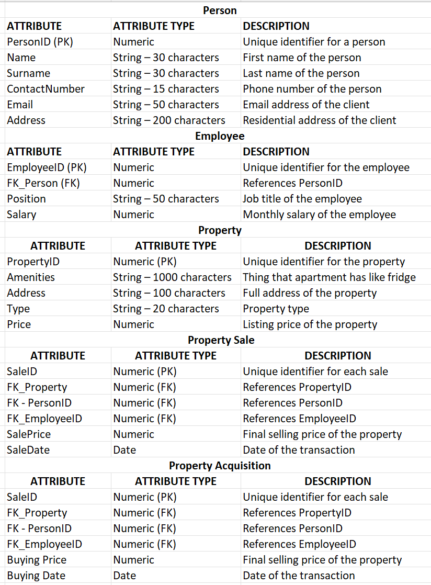

* 1. Marketing excel

Sheet 1 (Information about marketing in the real estate agency, each line describes one apartment, line 1 is a header row):

**Column A:** Property ID

Column B: Money Spent on Marketing

Column C: Number of Views on Our Website

Column D: Number of Views on Competition Website

Column E: Money Spent on Competition Website

Column F: Number of Views on Social Media

Column G: Money Spent on Social Media

Column H: Starting date of the campaign

Column I: Ending date of the campaign